Controversy over Lusitania |  | Difficulty
Controversy over Lusitania |  |  | 1

Name︰_______________ （ ） Class︰__________

Historical skill | Sum up features, interpret political cartoons
Related Textbook Content | 3A pp.28-29

Study the sources below and answer the following questions.

Source A Response from the German government to a battle in 1917
The US government proceeds on the assumption that the Lusitania was an ordinary unarmed merchant veseel. The German Government begs to point out that Lusitania undoubtedly had guns on board which were mounted under decks and masked when it left New York. The German Government believes that it acts in just self-defence when it seeks to protect the lives of its soldiers by destroying ammunition destined for the enemy.

Source B A cartoon published in the US in 1917
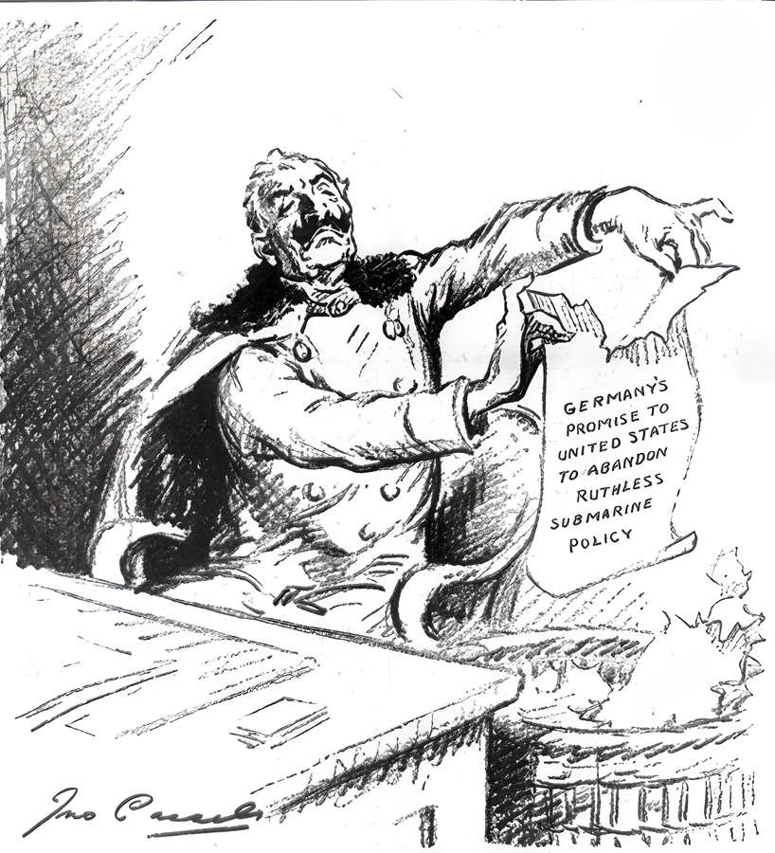

1. Infer and explain the battle mentioned in Source A was carried out in which region. Infer through source
Land in German territory
Sky in British territory
Sea in British territory
Explanation:______________________________________________________________

2. According to Source A, what were the different views of the German government and the US government on Lusitania? Analyse source
______________________________________________________________________
______________________________________________________________________

3. What was the main message of the cartoon in Source B? (add ) Analyse source
The US declared war on Germany.
Germany destroyed the peaceful relations with the US.
Germany declared war on the US.
The US was dissatisfied with decisions made by Germany.

4. In your opinion, would the cartoonist in Source B agree with view of the German government in Source A? Explain your answer with reference to the sources above. Express opinion
________________________________________________________________________
________________________________________________________________________
Answers

1.
Land in German territory
Sky in British territory
Sea in British territory
Explanation: The battle was related to Lusitania, and Lusitania was a ship.

2. The US government believed that Lusitania was an unarmed and ordinary merchant boat, while the German government believed that Lusitania was an armed ship loaded with guns.

3.

The US declared war on Germany.
Germany destroyed the peaceful relations with the US.
Germany declared war on the US.
The US was dissatisfied with decisions made by Germany.

4. Disagree. According to Source A, the German government believed that destroying Lusitania with ammunition destined for the enemy was an act of self-defence, whereas Source B depicted the actions made by Germany as tearing down a promise to the US to maintain peace. This shows that the cartoonist in Source B did not agree with views of the German government in Source A and was dissatisfied with the response made by Germany.

